PIONEER JUNIOR COLLEGE, SINGAPORE

JC 2 PRELIMINARY EXAMINATION 2010
HIGHER 1

CHEMISTRY 8872/01

Paper 1 Multiple Choice 21 SEPTEMBER 2010
Additional materials: Data Booklet
Multiple Choice Answer Sheet 50 MINUTES

READ THESE INSTRUCTONS FIRST

Write in soft pencil.
Do not use staples, paper clips, highlighters, glue or correction fluid.
Write your name, Centre number and index number on the Answer Sheet in the spaces provided unless this has been done for you.

There are thirty questions on this paper. Answer all questions. For each question there are four possible answers A, B, C and D.
Choose the one you consider correct and record your choice in soft pencil on the separate Answer Sheet.

Read the instructions on the Answer Sheet very carefully.

Each correct answer will score one mark. A mark will not be deducted for a wrong answer.
Any rough working should be done in this booklet.

A calculator may be used.

This document consists of 12 printed pages.

Pioneer Junior College [Turn Over
Section A

For each question, there are four possible answers labelled A, B, C and D. Choose the one you consider to be correct.

1 How many hydrogen atoms are there in 9.0 g of glucose, C₆H₁₂O₆ ?

A 6.0 x 10²²
B 3.6 x 10²³
C 6.0 x 10²³
D 3.6 x 10²⁴

2 Ten percent of the copper produced in the USA comes from bacterial leaching of low grade copper ores. In this process acidified water is sprayed onto the ore chalcopyrite. Bacteria then convert the insoluble ore into a solution containing iron and copper ions.

4 CuFeS₂ + 17 O₂ + 4 H⁺ 4 Cu²⁺ + 4 Fe³⁺ + 8 SO₄²⁻ + 2 H₂O

No change occurs in the oxidation state of copper

What changes in oxidation state occur for the iron and the sulfur in this reaction?

 | Change in oxidation state
 | Fe | S
A  B  C  D | -1  -1  +1  +1 | -6  +6  -8  +8

3 0.01 mol aqueous sodium sulfate (V), Na₂SO₄ was found to react completely with 0.02 mol hydroxylamine, NH₂OH. The half equation for the reduction of sulfate(VI) ion is given as shown.

2SO₄²⁻ (aq) + 10H⁺ (aq) + 8e⁻ S₂O₃²⁻(aq) + 5H₂O (l)

Which of the following could be the nitrogen containing product in this reaction?

A N₂O
B NO
C NO₂
D NO₃⁻

4 After 10 cm³ of a hydrocarbon had been burnt with 70 cm³ of oxygen, the gaseous mixture occupied a volume of 50 cm³ which was reduced by 30 cm³ by the addition of aqueous sodium hydroxide. Assuming all volumes are measured at room temperature and pressure, which one of the following is a possible formula of the hydrocarbon?

A C₃H₆
B C₃H₈
C C₄H₈
D C₄H₁₀

5 What is the volume of 0.100 mol dm⁻³ KMnO₄ aqueous solution required to oxidise a 25.0 cm³ aliquot of 0.300 mol dm⁻³ FeSO₄ aqueous solution?

A 10.00 cm³
B 12.50 cm³
C 15.00 cm³
D 25.00 cm³

6 The first seven ionisation energies of an element A are shown in the sketch graph.

Ionisation energy

Electrons removed
1 2 3 4 5 6 7

What could be the identity of element A?

A aluminium
B magnesium
C phosphorus
D silicon

7 Which of the species in their gaseous state shown below will be deflected by the largest angle in an electric field?

A ¹¹B³⁺
B ⁴He²⁺
C ⁹Be²⁺
D ¹H₂

8 Which of the following sets of species all have the same shape?

A  B  C  D | BCl₃  BeCl₂  CH₄  CO₂ | NH₃  CO₂  NH₄⁺  H₂O | PCl₃  SO₂  SiF₄  SO₂

9 The boiling point of the hydrogen fluoride is higher than Hydrogen iodide as follow:

Boiling point of HF = 19.4ºC > Boiling point of HI = –34.36 °C

Which of the options best describe the phenomenon?

A HF has higher boiling point due to stronger intermolecular hydrogen bonding than permanent dipole permanent dipole between HI molecules.
B HF has higher boiling point due to a higher H-F bond energy than H-I
C HF has higher boiling point due to stronger induced dipole induced dipole intermolecular forces than HI
D HF has a higher boiling point due to HF having stronger ionic bonds as it has a higher magnitude of lattice energy since fluoride ion in HF is smaller than Iodide ion in HI.

10 Compound B has the structure shown below:
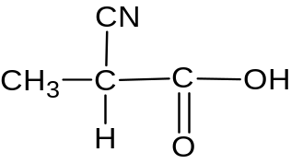

Compound B

Which of the following options shows the correct number of sigma and pi bonds?

Number of sigma bonds Number of pi bonds
A 10 3
B 10 1
C 11 3
D 11 1
11 Bromine is added to compound D shown below. The mixture is immediately placed in the dark and left until no further change takes place.

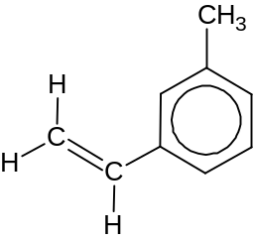 Compound D

What are likely to be the main product(s)?
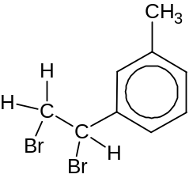
A

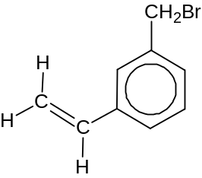
B

C
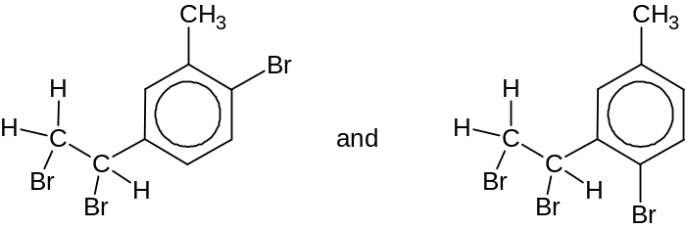

D
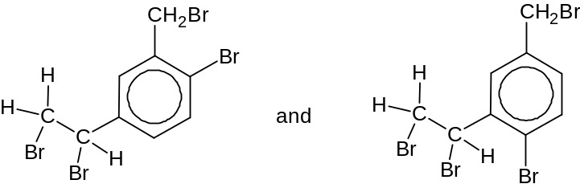

12 Which of the following options shows the correct reagents and conditions for
Step 1 and correct structure of Compound E?
Hot K₂Cr₂O₇(aq), H₂SO₄ (aq)

Step 1
CH₂(Cl)CH=CH₂ CH₂(CN)CH=CH₂ Compound E

 | Step 1 | Compound E
A | KCN in ethanol, heat | CH₂(CO₂H)₂
B | KCN in ethanol, heat | CH₂(CO₂H)CH=CH₂
C | KOH in ethanol, heat | CH₂(CO₂H)₂
D | KOH in ethanol, heat | CH₂(CO₂H)CH=CH₂

13 The following unsaturated hydrocarbon has the structure shown below:

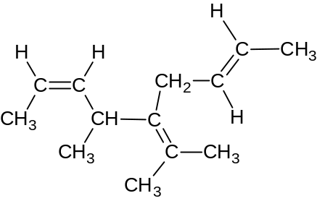

How many pairs of geometrical isomers of this molecule exist?

A 0
B 1
C 2
D 3

14 A compound F has the properties below:

- Fehling’s solution, on warming with F, retains its blue colour
- With hydrogen cyanide and aqueous sodium cyanide, F produces C₅H₇NO₂
- On reaction with warm aqueous alkaline iodine, yellow precipitate is formed

What could compound F be?

A CH₂=CHCOCH₂OH
B CH₃COCH₂CHO
C CH₃COCOCH₃
D CH₃COCH=CHOH

15 Aldehydes and ketones are produced industrially by the catalytic oxidation of alkenes. For example, ethanal is manufactured from ethene as shown.

catalyst
CH₂=CH₂ + ½ O₂ CH₃CHO

The process is also used industrially with but-2-ene, CH₃CH=CHCH₃

Which compound is obtained from but-2-ene ?

A CH₃CH₂CHO
B CH₃CH₂COCH₃
C CH₃CH₂CH₂CHO
D (CH₃)₂CHCHO

16 Compound G is an organic compound which has the structure shown below:

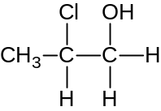

What deduction about compound G is wrong ?

A It is produced between reaction of prop-1-ene with aqueous chlorine.
B It forms white precipitate with hot ethanolic silver nitrate
C It contains a secondary halogenoalkane and primary alcohol functional group.
D It is oxidised to a ketone and carboxylate salt with hot alkaline potassium manganate

17 Which equation defines the enthalpy change of formation of carbon monoxide?

A C(g) + O(g) → CO (g)
B C(g) + ½ O₂(g) → CO(g)
C C(s) + ½ O₂ (g) → CO (g)
D C(s) + CO₂ (g) → 2 CO(g)

18 The energy diagram represents the reaction occurring with and without a catalyst.
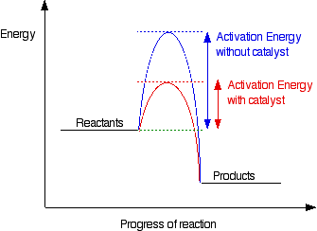

E₁
E₄
E₂

E₃

Which of the following statements is correct?

A E₄ is the activation energy for the reverse catalysed reaction
B The forward reaction with catalyst is endothermic
C The enthalpy change of reaction is reduced by using a catalyst
D The enthalpy change of reaction is (E₂ - E₃)

19 The enthalpy change of neutralisation for the reaction between sodium hydroxide solution and sulfuric acid is to be calculated.

2NaOH (aq) + H₂SO₄ (aq) Na₂SO₄ (aq) + 2H₂O(l)

40.0 cm³ of 1.00 mol dm⁻³ of sodium hydroxide solution is reacted with 10.0 cm³ of 1.00 mol dm⁻³ of sulfuric acid solution. The temperature rises by 5.4ºC.

If the density and specific heat capacity of all solutions are assumed to be 1.00 g cm⁻³ and 4.18 J g⁻¹ K⁻¹ respectively, what is the enthalpy change of neutralisation of the reaction?

A - 28.2 kJ mol⁻¹
B - 56.4 kJ mol⁻¹
C -112.8 kJ mol⁻¹
D -225.7 kJ mol⁻¹

20 In which reaction is ammonia acting as an acid?

A 2 NH₃ (l) + 2 Na (s) 2 Na⁺ NH₂⁻ (s) + H₂ (g)
B 2 NH₃ (g) + 3 CuO (s) 3 Cu (s) + N₂ (g) + 3 H₂O (g)
C 2 NH₃ (aq) + Ag⁺ (aq) [Ag(NH₃)₂]⁺ (aq)
D NH₃ (g) + H₂O (l) NH₄⁺ (aq) + OH⁻ (aq)

21 What is the pH of a 0.100 moldm⁻³ barium hydroxide solution, Ba(OH)₂ (aq) at 25ºC ?
( Given that ionic product of water, K_{w} = 1.00 x 10⁻¹⁴ mol² dm⁻⁶ at 25ºC )

A 0.70
B 1.00
C 13.0
D 13.3

22 The reaction between hydrogen and nitrogen monoxide can react to form nitrogen and steam.

2 H₂ (g) + 2 NO(g) N₂ (g) + 2 H₂O (g)

The rate of reaction is first order with respect to hydrogen and second order with respect to nitrogen monoxide.

0.100 mol dm⁻³ of H₂ and 5.00 mol dm⁻³ of NO (g) were put into a sealed flask of fixed volume. It was found that there was 0.0250 mol dm⁻³ of H₂ left 40 minutes later.

Which statement is true?

A An excess concentration of 5.00 mol dm⁻³ NO (g) is used so that the rate of reaction will remain constant as reaction proceeds.
B There was 0.0250 mol dm⁻³ of N₂ (g) left after 20 minutes.
C There was 0.0125 mol dm⁻³ of H₂ (g) left after 80 minutes.
D The unit of the rate constant is s⁻¹.

23 In acid solution BrO₃⁻ ions will slowly oxidise Br⁻ ions to Br₂.

BrO₃ ⁻ + 5 Br ⁻ + 6H⁺ 3 Br₂ + 3H₂O

The variation for the initial rate of reaction with the concentrations of the reactants was investigated in four experiments.

Experiment number | [BrO₃ ⁻] / moldm⁻³ | [Br ⁻] / moldm⁻³ | [H⁺] / moldm⁻³ | Relative rate
1 | 0.10 | 0.20 | 0.15 | 1
2 | 0.10 | 0.10 | 0.30 | 2
3 | 0.20 | 0.10 | 0.30 | 4
4 | 0.20 | 0.20 | 0.30 | 8

What is the rate equation for this reaction?

A rate = k[BrO₃⁻]² [Br⁻] [H⁺]
B rate = k[BrO₃⁻] [Br⁻]² [H⁺]
C rate = k[BrO₃⁻] [Br⁻] [H⁺]²
D rate = k[BrO₃⁻] [Br⁻] [H⁺]

24 Which of the following sets of oxides when added to water will form an acidic,
an alkaline and a neutral solution ?

A Al₂O₃ SiO₂ P₄O₁₀
B Na₂O MgO Al₂O₃
C MgO Al₂O₃ SiO₂
D MgO Al₂O₃ P₄O₁₀

25 Consider the period 3 elements and their compounds with their properties sketched in the form of graphs below:
Graph 1 Graph 2

Atomic number
Atomic number

What does Graph 1 and Graph 2 represent?

Graph 1 Graph 2
A melting point of elements first ionisation energy of elements
B melting point of elements atomic radius of elements
C pH of their chlorides in water first ionisation energy of elements
D pH of their chlorides in water atomic radius of elements

Section B

For each of the next 5 questions, one or more of the three numbered statements 1 to 3 may be correct.

Decide whether each of the statements is or is not correct (you may find it helpful to put a tick against the statements which you consider to be correct).

The responses A to D should be selected on the basis of

A | B | C | D
1, 2 and 3 are correct | 1 and 2 only are correct | 2 and 3 only are correct | 1 only is correct

No other combination of statements is used as a correct response.

26 Calcium has a lower first ionisation energy than magnesium.

Which statements help to explain this?

1 The outer electrons in calcium experiences greater shielding than that in magnesium.
2 The outer electron in calcium is further away from the nucleus of the atom than that in magnesium.
- The Calcium atom has eight more protons in the nucleus than the magnesium atom.

27 When propanone is reacted with hydrogen cyanide, the progress of the reaction can be followed by plotting the concentration of hydrogen cyanide against time. One such plot is given below:

[hydrogen cyanide] / mol dm⁻³

time / min
What conclusions can be drawn from this result ?

1 The reaction is zero order with respect to hydrogen cyanide.
2 For mixtures containing same concentration of propanone, the gradient of the line depends on the initial concentration of hydrogen cyanide.
3 The order of reaction with respect to propanone is one.
28 The reaction below shown is reversible. For every one mole of gaseous A₂ that dissociate, two moles of gaseous A atoms are produced.

1 A ₂ (g) 2 A (g) ΔH = 0 kJ mol⁻¹

Which of the following will not increase the yield of gaseous A atoms?

1 using a catalyst
2 increase in pressure
- increase in temperature

29 The diagram represents a simplified section of a catalytic converter as fitted into the exhaust system of a car. Harmful gases are converted into carbon dioxide, nitrogen and water vapour.
Platinum and rhodium catalyst
CO CO₂
Hydrocarbons H₂O
NO_{x} N₂

Which reactions between the stated compounds could take place on the surface of the catalyst?

1 carbon monoxide + hydrocarbons → carbon dioxide + water
2 carbon monoxide + oxides of nitrogen→ carbon dioxide + nitrogen
3 hydrocarbons + oxides of nitrogen → carbon dioxide + water + nitrogen

30 Which type of reaction(s) are not shown in the synthesis shown below ?

CH₃CH₂Cl CH₃CH₂CN CH₃CH₂COOH CH₃CH₂CH₂OH

1 Oxidation
2 Reduction
3 Substitution

1 B | 7 B | 13 C | 19 B | 25 A
2 D | 8 C | 14 D | 20 A | 26 B
3 A | 9 A | 15 B | 21 D | 27 D
4 B | 10 C | 16 A | 22 B | 28 A
5 C | 11 A | 17 C | 23 C | 29 C
6 D | 12 B | 18 D | 24 D | 30 D

* End Of Paper *

